

Bradley Sleep Lab/COBRE Poster Printer Guidelines

Pre-Arrival
- Fill out a consultation request to print a poster on Bradley Hospital COBRE Center for Sleep and Circadian Rhythms website: https://bradleycobre.org/forms/consultation-request/
  - Under “Core Services Inquiry,” select “Administrative Core.”
  - Under “Nature of Inquiry,” select “Equipment or Lab Access” and provide information about your printing timeline in the Description box.
  - Please schedule print time a minimum of 5 days before you need your poster.
    - Contact Sleep Lab RAs by emailing them to schedule a time.
      - Contact information in the footer of this document.
      - Please have a white background, but if you must use color, please set opacity to 50% or less.
      - Please acknowledge the “E.P. Bradley Hospital COBRE Center for Sleep and Circadian Rhythms in Child and Adolescent Mental Health (P20GM139743)” and include the “star child” on your poster (see below for image and text).
At the Lab
- Call the Sleep Lab to announce your arrival (Tel: 401-421-9440). An RA will let you into the Sleep Lab’s Annex (200 Duncan Dr) to print.
  - Even if you know the pin code to the Annex, announce your arrival by calling the lab.
- Use the Poster Printing Instructions Document (emailed to you and available in the Poster Printing Room) for your printing session.
  - Leave the red swivel chair where it is by the mouth of the printer. It is there to help catch your poster.
  - Please only print one poster on glossy paper. If you would like a test print on matte paper, please allow at least one business day for the paper to be switched.
- Printing lasts about 25 minutes for a 48”x36” poster and an additional 5 minutes for initial drying.
  - Plan to leave the poster overnight in the Annex to fully dry to prevent smudging and lay your poster flat on a table.
Troubleshooting
- Please do not, under any circumstances, touch the printer other than the power button or the “form feed and cut” button if using fabric paper.
  - If the printer seems to jam or stops printing before the poster is complete, do not try to fix it yourself. If the printer is providing instructions on how to remedy the problem, do not touch the printer. Contact Sleep Lab RAs via phone or email for assistance.

FAQs
- The ink/toner is low. Can I replace it myself?
  - No, contact Sleep Lab RAs by emailing them or calling them at 401-421-9440.
- The paper roll is empty. Can I replace it myself?
  - No, contact Sleep Lab RAs by emailing them or calling them at 401-421-9440.
- The loaded paper roll is glossy and I would like to print on the fabric paper. Can I switch out the rolls.
  - Unless given express permission from Drs. Carskadon and Saletin of the Sleep Lab, no. If you have been given permission from the lab’s PIs, contact Sleep Lab RAs by emailing them and requesting assistance.
- I have printed with the Sleep Lab before, understand the procedures, and know the pin code to the Annex. Now my colleague would like to print with the Sleep Lab. Can I let them into the Annex and get them started myself?
  - No, everyone needs to schedule a print time with the Sleep Lab RAs by so we can keep track of who has been in the Poster Room.
Image and Text to Use to Acknowledge the COBRE


E.P. Bradley Hospital COBRE Center for Sleep and Circadian Rhythms in Child and Adolescent Mental Health (P20GM139743)

Poster Printing Instructions
(as of March 1, 2024: Stored on Server under Storage/ATTN EVERYONE)

REMEMBER MAC’S RULE: If you want to test print, use plain paper. Use the fabric or glossy (more expensive) paper to print the final version of your poster.
GUIDELINES FOR CREATING A POSTER:
- Our poster printer can print posters 3 ft. x 4 ft (36 x 48 inches).
  - Be sure to check the instructions for poster size from the venue it will be displayed at.
- Make sure the poster has a white background, but if you must use color, please set opacity to 50% or less.
- To create a poster in Powerpoint that is the correct size, do the following:
  - Select File > Page setup
  - Next to Slides sided for: choose Custom
  - IF you would like a Portrait poster, enter Width = 36, Height = 48 and make sure the icon for Portrait slide orientation is selected
  - IF you would like a Landscape poster, enter Width = 48, Height = 36 and make sure the icon for Landscape slide orientation is selected
  - Choose OK
- Save your Power Point presentation as a PDF (1) on a USB key or (2) email to yourself.

WHEN YOU ARE READY TO PRINT:
- Go to the Annex building (200 Duncan Drive) at your scheduled printing time, and call the lab (Tel: 401-421-9440) to have a Sleep Lab RA let you in.
- Once in the Poster Room, turn on the poster printer (button on the lower left when facing the printer), if it is not already on (green light on button is lit)
- The printer will initialize itself. Let it do its thing.
- Log into the desktop in the Poster Room using your credentials.
- Open your PDF document in Adobe Acrobat.
- Click “Print” by selecting the “print” icon in the upper left corner, using the keystroke Ctrl+P, or going to the “File” tab and selecting “Print from the drop down menu.
- Choose Design 500P542 + HPGL2 Card as your printer and click on “Properties.”
  - Circled in red in Figure 1.

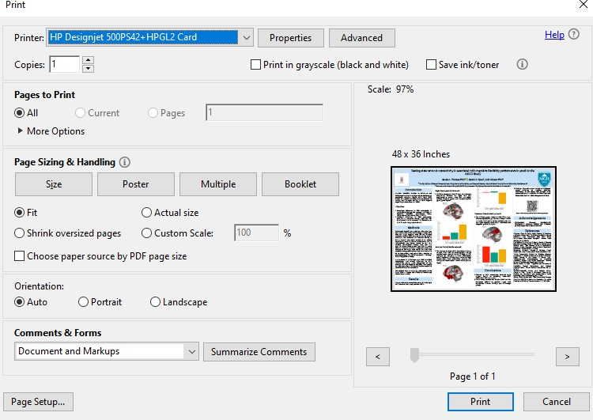
Figure 1

- In the “Paper/Quality” tab under Paper Options, ensure that the dimensions are correct.
  - Area of interest is circled in red in Figure 2.
  - Portrait: width = 36, height = 48.
  - Landscape: width = 48, height = 36.
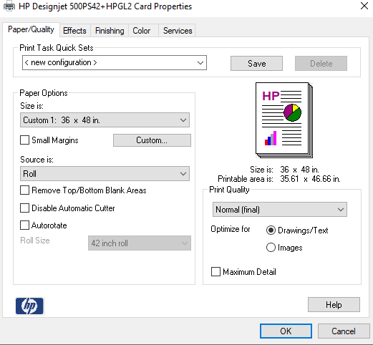
  - Disregard 8a/b if the venue requires different poster dimensions.
Figure 2

- Navigate to the “Services” tab
  - Circled in green in Figure 2.
- Click on the Hammer Icon under Troubleshooting Menu
  - Circled in red in Figure 3.

- Ensure that “Send Job as a Bitmap” and “Enable SpoolSmart” are selected
  - Circled in green in Figure 3.
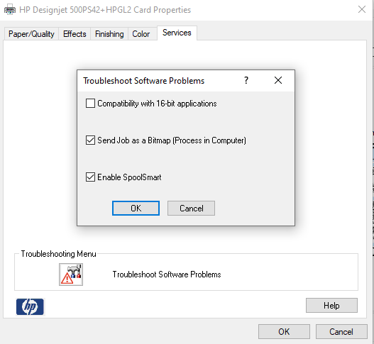
Figure 3

- Select OK, then select OK again to return to the Print Setup page
- On the Print Setup Window, under Orientation, select Auto.
- Ensure the dimensions displayed above the poster image match the desired dimensions.
- Select Print.
- After you tell the file to print on the PC, the Job Management menu on the printer will tell you that the file is printing.
- When the poster is done printing, the printer will automatically cut the poster for you.
  - Note: when you print on glossy paper, it dries for 5 minutes before cutting. Just wait.
  - Note: when you print on fabric paper, it does not automatically cut the poster. Press the form feed and cut button on the printer to cut the poster after it dries.
- The poster will need to dry further, laying flat on a large surface for about one day.

NOTE: The Lab has a paper cutter that is housed in the Poster Room and will be available to trim posters.

SLEEP LAB STAFF ONLY

CHANGING THE ROLL (Do Not Use Unless Trained):
- Press the menu button on the printer,
- Press the up-arrow twice to select paper menu. Press Enter.
- Scroll using the arrow to “Select Paper Type.” Press Enter.
- Scroll to the paper type that is loaded into the printer (plain paper for a practice print, glossy paper or canvas (fabric) for the final version).
- To Change the Roll:
  - While in the Paper menu, select Unload Roll. Press Enter.
  - Follow Instructions on the display & the 6 pictures on the top of the printer to change the roll. Make sure that you wind the roll up so there is no excess paper.
  - Sometimes it takes a few tries to align the paper in a satisfactory way.

Troubleshooting Note: IF the paper jams when initializing, check the paper trimmer attachment to remove ALL stuck paper (including tiny curls of paper within the trimmer itself – a paperclip may work well for this (MAC troubleshooting, 6/7/12)

